  ICAPE  International |  |  |  | Customer Name: Valentinea
 |  |  |  | Customer P/N: SI944D
 |  | Note I: Please declare your technical questions with simple, clear, logic and professional sentence in English.  Note II: Please kindly check the following technical questions item by item and reply within a working day |  | Supplier P/N: 042113091A0
Question |  |  | Suggestion |  | Client Reply
1 | See fig1，the space between the highlight SMD is too small to keep solder mask bridge.  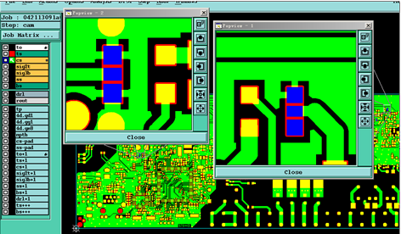 |  | Suggest not to make solder mask bridge and build as through solder mask opening.  Please confirm. |  | OK
2 | Some PCB manufacture specification is not defined, we suggest do as below suggestion:  - Base material: FR4, TG130°;  - Board thickness:1.6mm+/-10%;  - Finish copper thickness:35um on outer layers, and min. 24.9um for inner layer per IPC 6012 Class 2;  - Surface finish: ENIG;  - Solder mask color: Green  - Silkscreen color: White. |  | Please help to confirm from 1 to 6. |  | OK
3 | See below picture, there is a slot on the edge area of board in given panel drawing, but there isn’t slot in actual gerber file.  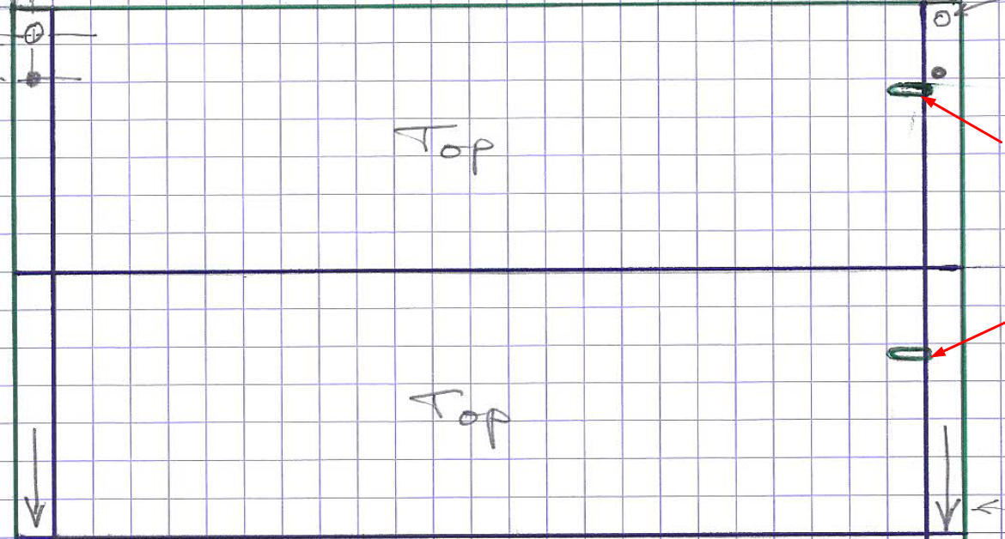 |  | Suggest to build board as per gerber without slot here, please confirm. |  | OK
4 | Attached is our working gerber based on your panel drawing. |  | Please check carefully and confirm if it’s ok? |  | - The copper arrows are missing on the holding strips of the cs file.  - No need for fiducials on ss gerber.  - The ts and bs gerbers show the routing and should not.  - Please make a pdf of the panel construction as usual.  Please re-send the complete archive when finished.  OK

Supplier: Checked by: | Henry Date: 2016/12/30 |  |  | Customer:  Approved by: | Date:

